PSG COLLEGE OF TECHNOLOGY, COIMBATORE -4
DEPARTMENT OF APPLIED MATHEMATICS AND COMPUTATIONAL SCIENCES
III M.Sc Data Science - 5th SEMESTER
15XD56 - JAVA PROGRAMMING LAB
PROBLEM SHEET – 4

Objectives: Write programs to demonstrate
- Abstract class ii) Interface and Multiple inheritance
- Consider the following diagram that represents a library system that records the books that have been borrowed. There are three kinds of books: regular books, reference books, and audio books. Reference books can be taken out for just two days, while other kinds of books may be borrowed for two weeks. The overdue fees are Rs.1/- per day for reference books and regular books, and Rs.2/- per day for audio books.
Audio books and regular books have both authors and titles; reference books only have titles.
The day when the book is taken out and the day due are counted as days since the library opened on New Year’s Day in 2019.
+-------+
| IBook |
+-------+
|
| | |
+---------------+ +---------------+ +---------------+
| Regular
Book | | RefBook | | AudioBook |
+---------------+ +---------------+ +---------------+
| String title | | String title | | String title |
| String author | | int dayTaken | | String author |
| int dayTaken | +---------------+ | int dayTaken |
+---------------+ +---------------+
Design the classes that represent the library borrowing system.
- Define the abstract class Book and lift those fields that can be lifted to this class.
- Design the method daysOverdue that consumes the number that represents today in the library date-recording system and produces the number of days this book is overdue. If the number is negative, the book can still be out for that many days.
- Design the method isOverdue that produces a boolean value that informs us whether the book is overdue on the given day.
- Design the method computeFine that computes the fine for this book, if the book is returned on the given day.
Implement the above specifications carefully with an abstract class and concrete classes.

- Define an abstract class named PassengerTicket that holds information related to any type of ticket. It must have the properties listed in the table below. Note that the departure and issue date time must be in the form of “yyyy/mm/dd HH:mm:ss”.
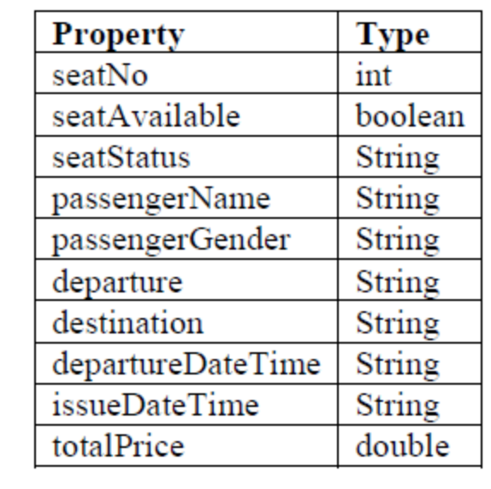
Define the all appropriate accessor and mutator methods related to the properties. Also add a default constructor that initializes the all properties to unknown but dateTime properties to “yyyy/mm/dd HH:mm:ss” and total price and seatNo to zero. Set seatAvailable as true.
Total price varies among various types of tickets. So you are supposed to make setTotalPrice method as an abstract method. Also add toString method to get information about the ticket.
B). Now define a class named BusTicket that is derived from the PassengerTicket class. It has some additional properties shown in Figure: Add a no-argument constructor that initializes both distance and serviceCharge to 2.5 .
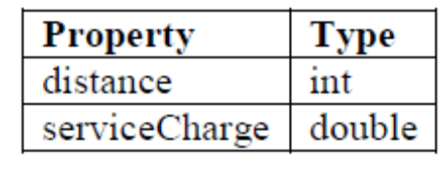
Add a constructor that takes distance and service charge as arguments and set them to the appropriate instance variables. Override the setTotalPrice method as follows: Calculate total price as distance*0.08 + service charge. Invoke the setTotalPrice method at the end of each constructor.

C)Create an interface named TicketOperations. It has the following method signatures:
public boolean makeReservation(BusTicket ticket, String name, String gender);
public boolean cancelReservation(BusTicket ticket);
public boolean buyTicket(BusTicket ticket, String name, String gender);
public boolean cancelTicketSold(BusTicket ticket);
The return type boolean in all method signatures indicates that whether the indicated operation
has been completed successfully or not.
D)Define a class named Officer that implements the TicketOperations interface. It has the following instance variables:

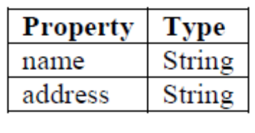
Add a no-argument constructor which initializes name and address as unknown.
Add a constructor that allows the user of the class to set all instance variables. (i.e. Officer(String name, String address)) Add all appropriate accessor and mutator methods.
Override the methods of the interface :
makeReservation(BusTicket ticket, String name, String gender): Set ticket information
appropriately. It includes setting the name and gender of the passenger who has bought the
ticket. Set seat availability to false and seat status to “RESERVED”. Finally set the issue date
time of the ticket as follows
import java.text.DateFormat;
import java.text.SimpleDateFormat;
import java.util.Date;
DateFormat df = new SimpleDateFormat("yyyy/MM/dd HH:mm:ss");
Date date = new Date();
String dt = df.format(date);
ticket.setIssueDateTime(dt);
At the end, return true.
• buyTicket(BusTicket ticket, String name, String gender): Set ticket information appropriately.
It includes setting the name and gender of the passenger who has bought the ticket. Set seat
availability to false and seat status to “SOLD”. Finally set the issue date time of the ticket as
indicated before. At the end, return true.
• cancelReservation(BusTicket ticket):Set seat availability to true and seat status to
“AVAILABLE”. Set passenger name and gender to empty string. Also set the issue date time
to “yyyy/MM/dd HH:mm:ss”. At the end, return true.
• cancelTicketSold(BusTicket ticket):Set seat availability to true and seat status to
“AVAILABLE”. Set passenger name and gender to empty string. Also set the issue date time
to “yyyy/MM/dd HH:mm:ss”. At the end, return true.

